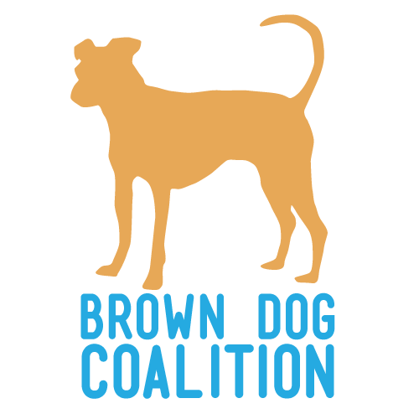
Dog Adoption Application

Thank you for your interest in adopting a dog! Adopting is a very rewarding experience that helps save animals lives. This application is an important step for us to get to know you so we can match our dogs with proper forever families. The application does not guarantee you a dog. Please complete each section of the application and provide as much detailed information as possible.

Please save this form to your own computer. When complete, email to browndogcoalitionandrescue@gmail.com

Section 1 – Personal Information
Applicant’s Name:
Co-applicant’s Name:
Address: City: State: Zip:
Best way to contact you is:
Cell Phone: ( ) Home Phone: ( )
Email Address:
Occupation: Date of Birth:

Section 2 – Household Information
How many adults live in your home? Are all adults on board?
How many children (under 18) live in your home? List their ages:
Do children visit your home often? If yes, list ages:
Describe your home’s activity level:
Does anyone in your household have allergies to animals? If yes, explain
What type of home do you live in (house, condo apartment, etc.)?
If you rent, please provide landlord information:
Landlord Name: Number: ( )
Do you live on a busy or quiet road?
Do you have a yard with a physical fence? Height: Is it buried/secure?

Section 3 – About Your New Dog

Which dog are you applying for?

If you are not looking for a specific dog, tell us what you are looking for in a dog. Include info on age, size, sex, and energy level:

Who is going to be the primary caretaker of the dog?

Are you planning on crate training the dog? If yes, how do you plan to use the crate?
Will you take your dog to obedience training?
Have you had previous experience training dogs? If yes, what methods have you used?
How do you plan on exercising your dog?

If a behavioral issue arises, what would you do?

Are there any behaviors that you are not willing to work on?

Under what circumstances would you return a dog?
How long will the dog be left unattended, and where will he/she be?
Who will take responsibility for this animal if you are no longer able?
What do you estimate the annual cost of a dog is?
Are you willing to give the dog the proper time to adjust to your home, even if it takes more than 30 days and it involves some house training accidents?

Section 4 – Pet Experience
How many pets do you currently have?
How many pets have you had in the last 5 years?
*Please fill out the following information for any animals you currently have or have had in the last 5 years, continue on next page if more space is needed*

Name: Breed: Age: Sex:
How long have you had the animal? Is this a current pet?
If you no longer have this pet, why?
Is the pet spayed or neutered? Is the pet UTD on vaccines?
Veterinary Information: Name Phone: ( )
*We will be contacting your vet, so please call them and give them permission to talk to us*

Name: Breed: Age: Sex:
How long have you had the animal? Is this a current pet?
If you no longer have this pet, why?
Is the pet spayed or neutered? Is the pet UTD on vaccines?

Name: Breed: Age: Sex:
How long have you had the animal? Is this a current pet?
If you no longer have this pet, why?
Is the pet spayed or neutered? Is the pet UTD on vaccines?

Have you ever had to surrender an animal? If yes, why?

Section 5 – Personal References
Please provide 3 personal references (at least 2 non-family members):
Name: Relationship: Phone:
Name: Relationship: Phone:
Name: Relationship: Phone:
Is there any additional information you would like to provide about yourself or the dog you would like to adopt?

Section 6 – Signature (By signing this form you agree all information provided is truthful.)

I have filled out this application honestly and to the best of my ability. I understand that omission of information or failure to answer all questions on this application will delay the application process. I understand that completing this application does not guarantee me a dog.

Signature:

