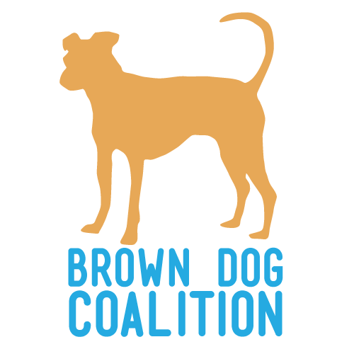
Dog Adoption Application

Thank you for taking the first step towards adopting a Brown Dog! Please complete each section of the application and provide as much detailed information as possible. The application does not guarantee you a dog. We will respond within 48 hours of submitting your application.

Please save this form to your own computer. When complete, email to:

browndogcoalitionandrescue@gmail.com

Section 1 – Personal Information
Name:
Co-applicant (if applicable):
Address:
City: State: Zip:
Email Address:
Home Phone: ( ) Cell Phone: ( )
Best way to contact you is (Email, Phone, Text):
Date of Birth:
Occupation:

Section 2 – Household Information
Please list all humans living in your home (name, age, relationship, occupation):

Are all adults on board?
Do children visit your home often? If yes, list ages:
Describe your home’s activity level:
Does anyone in your household have allergies to animals? If yes, explain
What type of home do you live in (house, condo apartment, etc.)?
If you rent, please provide landlord information:
Landlord Name: Number: ( )
Do you have a yard with a physical fence? Height:
Is it buried/secure?
Do you live on a busy or quiet road?

Section 3 – About Your New Dog

Which dog are you applying for? Please list only one.

If you are not applying for a specific dog, tell us what you are looking for in a dog. Include info on age, size, sex, and energy level:

Who is going to be the primary caretaker of the dog?

Are you planning on crate training the dog? If yes, how do you plan to use the crate?
Will you take your dog to obedience training?
Have you had previous experience training dogs? If yes, what methods have you used?
How do you plan on exercising your dog?
Will your dog be kept on a runner or tied outside?

If a behavioral issue arises, what would you do?

Are there any behaviors that you are not willing to work on?

Under what circumstances would you return a dog?
How long will the dog be left unattended, and where will he/she be?
Who will take responsibility for this animal if you are no longer able?
What do you estimate the annual cost of a dog is?
Are you aware that dogs are active and shed all year long?
Are you willing to give the dog the proper time to adjust to your home, even if it takes more than 30 days and it involves some house training accidents?

Section 4 – Pet Experience
Please list all animals currently living in your home (name, age, breed, gender, spayed/neutered):
Include name, breed, age, gender, spayed/neutered, up to date on vaccines, heartworm preventatives, date/year of adoption.

Please describe any other animals you have had in the last 5 years:
Include name, breed, age, gender, spayed/neutered, up to date on vaccines, heartworm preventatives, the reason you no longer have the animal

Veterinary Information: Name Phone: ( )
*Please let them know we will be contacting them. Failure to do so could delay the processing of your application.*

Under whose name is your pet listed at the vets?
Have you ever had to surrender an animal? If yes, why?

Section 5 – Personal References
Please provide 3 personal references (at least 2 non-family members):
Name: Relationship: Phone:
Name: Relationship: Phone:
Name: Relationship: Phone:
Is there any additional information you would like to provide about yourself or the dog you would like to adopt?

Section 6 – Signature (By signing this form you agree all information provided is truthful.)
I understand that Brown Dog Coalition is not able to guarantee any animal's age, breed, or temperament. I understand that omission of information or failure to answer all questions on this application will delay the application process. I understand that completing this application does not guarantee me a dog.

Signature:

